Chapter 8 Rocks
extra worksheet 1: Weathering and surface area
Science understanding Logical/Mathematical, Visual/Spatial
This worksheet is an extension of Pearson science 8 Activity Book Worksheet 8.3 Weathering experiment and will help you to understand what happened in the experiment done by Sita and Glenn. To help you understand the results, you can model what is going on using an apple. Cut a piece of apple into a cube with 2 cm sides.

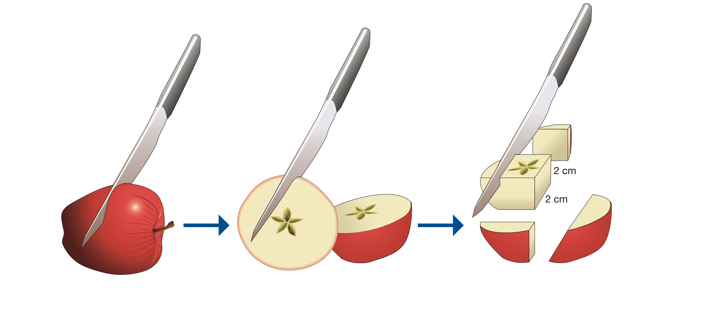
Figure 8.1.1

Finding the surface area
You can calculate or measure the total area of apple on the outside of this piece. There are six faces.
The area of each face = 2 x 2 = 4 cm².
The total surface on the apple cube = 2 x 2 x 6 = 24 cm².

Finding the volume
The volume of a cube is found by the formula
volume = length x breadth x height
The total volume of the cube of apple = 2 x 2 x 2 = 8 cm³.

Increasing the surface area
Now cut the apple cube into eight cubes with 1 cm sides. Do this by cutting the cube in the middle of the length, the breadth and the height. Use Figure 8.1.2 to help you.
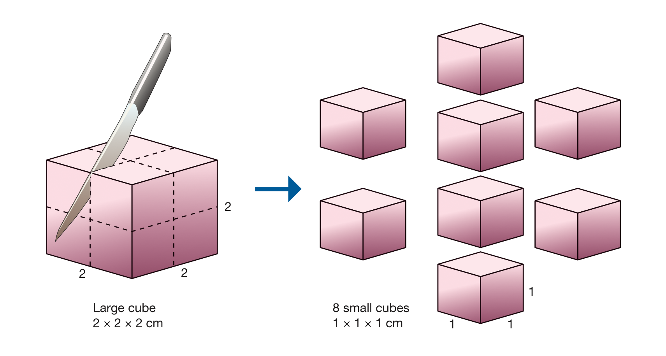
Figure 8.1.2
The total volume of these 8 cubes is still 8cm³. So there is still the same amount of apple in them as in the single large cube. But there are now eight small cubes and each has six faces.

Questions
1 Calculate the amount of surface now on one small cube. Show your working.

2 Calculate the total surface of all 8 small cubes together. Show your working.

3 Compare the total surface of the 8 small cubes with the surface on the large cube. Show your working.

Now imagine the apple is like the marble rock that Sita and Glenn used in their experiment. The amount of surface exposed is important, because this is what the acid attacks first. The acid can only reach the inside by gradually removing the surface. If a big surface is exposed the acid can attack it all at once, so more rock is reacting with the acid all the time.
4 Explain how Worksheet 8.3 and this extension worksheet have helped you understand why physical weathering can help chemical weathering break down rocks.

